**08343 - Commercial Games Development ACW1**

**Initial Concept Design**

**Game Introduction:**

As the only man on earth with superior knowledge you’re protecting the human race from an alien invasion! Use objects in your in backpack to shield yourself from the alien weapons!

**Game Objectives:**

Stay alive as long as possible, protect the human race!

Use objects in your backpack to protect against various alien weapons

**Story:**

The earth is under attack from an alien race. Being the only human in the world with the power and knowledge, you must step forward to save the world! Shield yourself from the alien rays before they hit you.

**Gameplay:**

The player must stay alive as long as possible by hiding behind each of the inventory items when specific weapons/rays have been fired by the alien. The ray will automatically follow the player. Once the weapon hits an object, that object will vanish (only one use) and the player will either survive or perish (dependent upon object hidden behind, see table below). This makes the game progressively easier as choices will be narrowed down the further the player is in the game.

The choice of weapon/ray the alien uses will be random, but only used once. The rate at which the ray progresses down the screen toward the player should be approximately 7 seconds; this gives the player ample time to move the character to the desired position with a little thinking time.

By pressing either ‘R’ or ‘B’ the player can pause the game, move to the ray or backpack screens. Both these screens provide information regarding comparative strength and weakness of each object or ray. After the 7 seconds the ray will hit the selected object shield, every time this happens a screen will be shown in which reasoning for their survival/game over will be displayed. If the player used the correct shield to survive the game will continue minus the used object and ray. If the player fails the game will start from the beginning. Each time a level is complete the score and percentage complete will be calculated and displayed.

|  |  |  |  |  |
| --- | --- | --- | --- | --- |
| Weapon/Ray | Colour | Shape | Protection | If Hit (action) |
| Gamma Rays | Yellow | Solid Line | Thick Lead Shield | Die |
| Beta Rays | Blue | Solid Line | Plastic Shield | Die? |
| Infra Red | Red | Dashed Line | Tin Foil | Burn? |
| Ultra Violet | Violet | Solid Line | Sun Glasses, Sun Cream | Sun Burn (Player Turns Red) |
| X rays | Light Blue/White Flash | Small straight line, alternating colours | Brick Wall | Cancer |
| Cosmic Rays | Yellow | Solid Line | Thick Lead Shield | Die |
| Laser | Red | Solid Line | Mirror | Blind? |
| Sound Wave | White | Compression wave (horizontal) | Earplugs/Headphones | Deaf |

**User Interface:**

The game will be presented in 2D; the graphics will not be particularly advanced, sprite based. The game will be in full colour. Score and percentage complete indicators will be shown at the top of the screen, score on the left and percentage complete on the right. Along the right side of the screen the backpack inventory will be shown, linking the object image with a text description. The player (human) will be at the bottom of the screen, with the alien shooting rays from the top of the screen. The player must move behind the object which they think would provide adequate protection from the fired ray.

**Controls:**

The left and right arrow keys will be the main buttons, moving the player respectively left and right on screen. At any point in the game the player can press B (for backpack) to read about items in the backpack. At any point in the game the player can press R (for ray) to read about each of the weapons and their strengths/weaknesses.

**AI:**

The game features very little AI, the alien will be stationary firing random rays at a slow rate. The ray must automatically follow the player until an object is hit.

**Sound:**

Sounds will be present when playing the game, although they will be short and fairly quiet, to avoid annoying players/spectators. Sounds included will be a generic firing ray noise and an explosion when an object is hit. This will not include any theme music.

**Analysis of learning Components of the Game:** NEEDS EXPANDING

If hit by any of the above weapons/rays the game is over, a screen will be shown describing the ray fired and which object the user should have chosen to provide protection. This is based on intrinsic learning because the player learning but not directly, they’re learning as part of the story line. At any point in the game the user can, by choice, press a button to learn about each individual ray. Again the teaching aspect is buried within the storyline.

Without prior knowledge the user will probably die, the more the user plays the more they are likely to learn.

**Market Analysis:** NEEDS EXPANDING

(Figure 1)

The graph shows a sample of questioned gamers on their favourite genres. As seen, the educational percentage is only 4%, which is a very specific market. This can be seen as an advantage and a disadvantage. On the one hand it means competition is likely to be small, but the market share of potential customers is also very small. The game proposal crosses the boundary of educational onto the arcade platform, thus increasing both these factors very slightly.

The figure 2 shows an almost equivalent game. Unfortunately a large amount of games based on flash are available online for free personal use.

Checking large online retailers reveals a small number of educational games available. One of these games is shown in figure 3

As seen the price of educational games are very small when compared to the more mainstream genres like FPS’s and strategy. Most educational game cost around £5-£10.

**Intellectual Property Right**

IPR has not been discussed with the client therefore the company can assume ownership of the finished product. For this reason long term business goals can be created with the intention of marketing/selling the game further after initial sale with the current client.

**Development Costs:**

Development costs for this project can be split up into 4 main groups:

* Time Resources
* Fixed Resources
* Support Resources
* Tools

Time Resources – Coding, Concept Art, Testing + Bug Fixing

Fixed Resources – Heating, Lighting, Rent, General Consumables

Support Resource – Secretarial, Systems, Cleaning

Tools – PC’s, Development Hardware, SDK’s, Software, Middleware, Compilers

400 hours work is estimated, using 6 programmers/designers.

At an hourly rate of £20 this totals £8000

Time Resources = £8000

Fixed Resources = £5000

Support Resources = £3000

Tools = £8000

The total estimated cost for the project is £24000

**Business Plan:**

**Short Term Goals:**

The short term goals are to provide a satisfactory game for the customer. Keep in time with the project schedule and within budget.

**Long Term Goals:**

After providing the game to the user the company is free to do with the game what it wishes. A suggested goal is then to advertise the game through online adverts and sell to prospective customers.

**Description of Product:**

The product is a simple educational game based on intrinsic learning to provide the user with a fun way to learn about the various effects of waves, radiation and objects that will provide protection against them.

**Appendix**

Figure 1

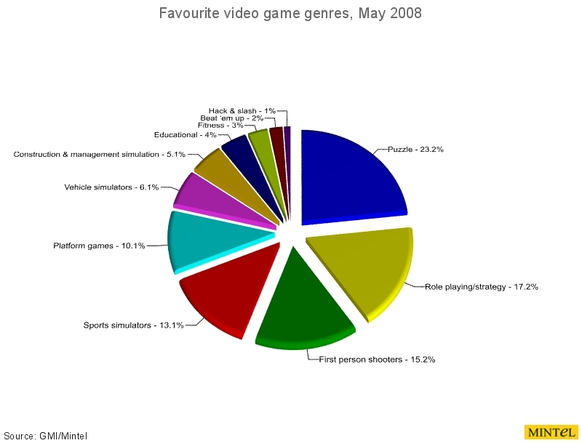

Figure 2: <http://funschool.kaboose.com/formula-fusion/games/game_comets.html>

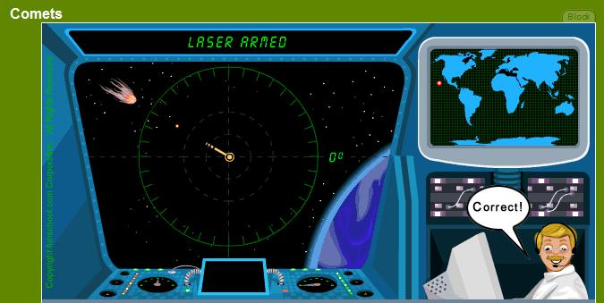

Figure 3

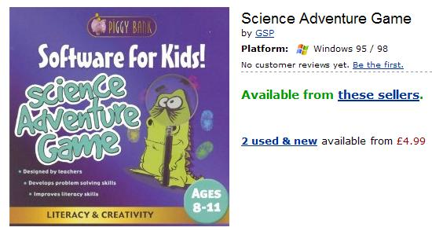

**Story Board:**

1. Game introduction, contains the game logo, introduction, controls.
2. Backpack screen. Available at any time by pressing ‘B’.
3. Ray screen. Available at any time by pressing ‘R’.
4. Main fighting screen.
5. Info screen – reasons why chosen protection succeeded/failed.
6. Game complete screen. Congratulation message.